🌐 Azure Front Door vs Azure Traffic Manager
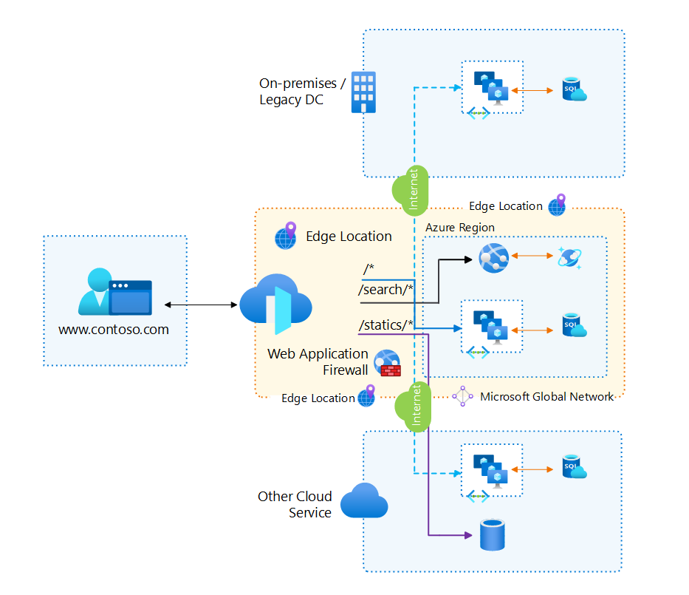
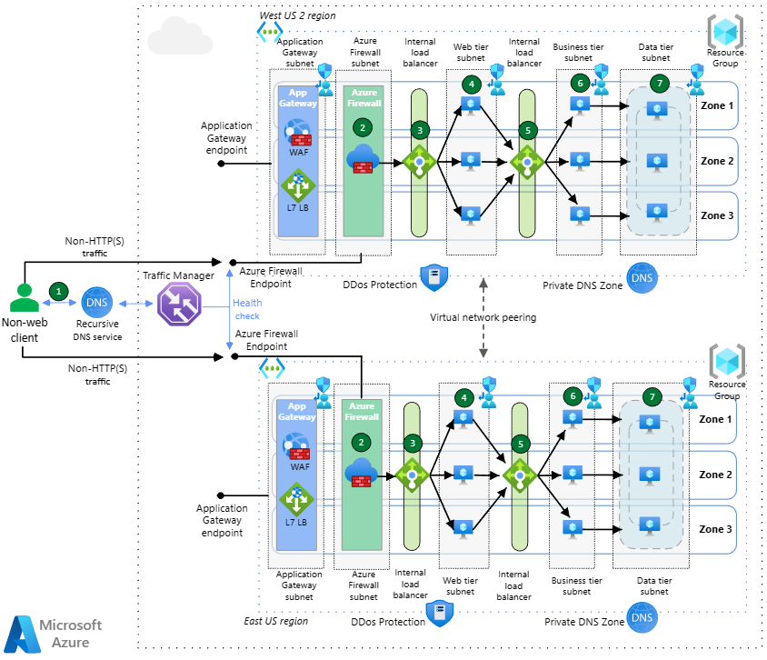
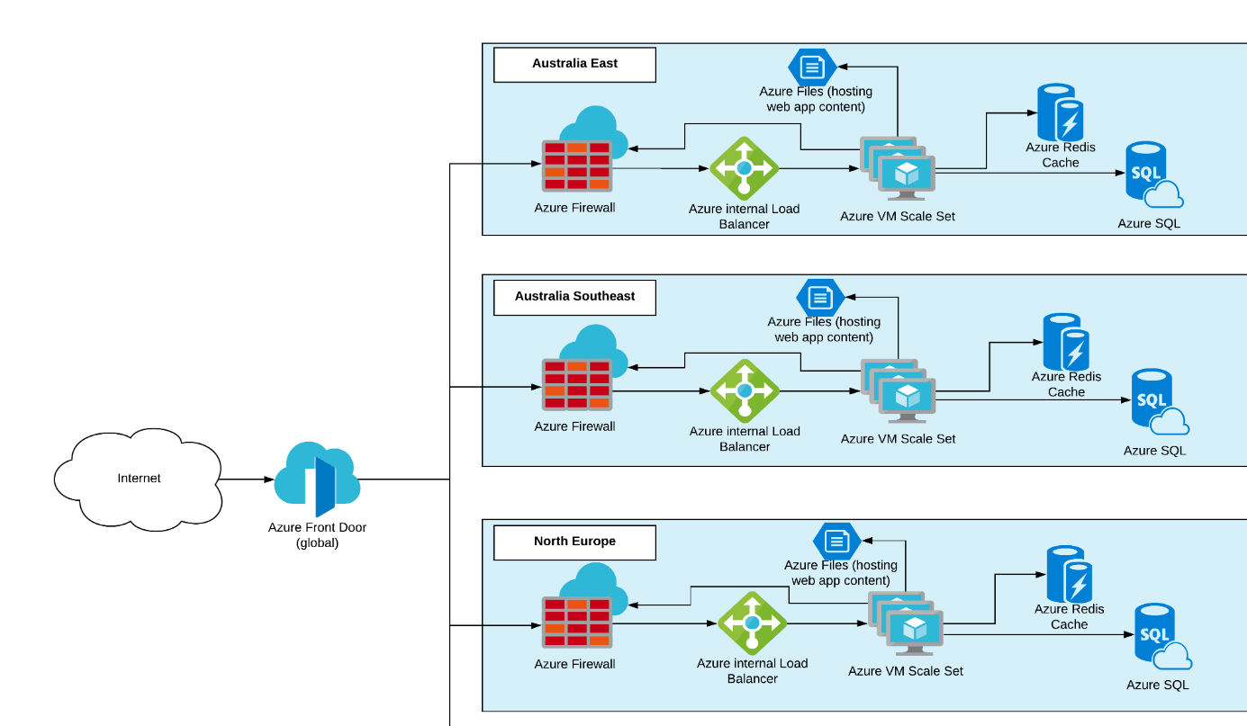
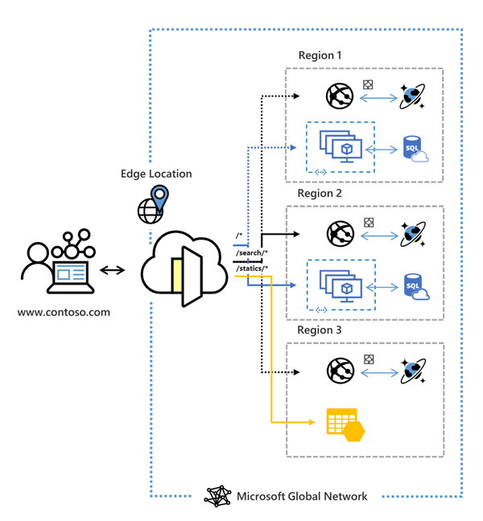

🔹 What are they?
Azure Front Door
A Layer 7 (HTTP/HTTPS) global entry point that provides:
- Global load balancing
- CDN
- Web Application Firewall (WAF)
- SSL termination
- Path-based routing
Think of it as a global reverse proxy at Microsoft’s edge.

Azure Traffic Manager
A DNS-based traffic routing service that:
- Routes users to the nearest/healthy endpoint
- Works for any protocol (HTTP, HTTPS, TCP, UDP)
- Does not proxy traffic
Think of it as smart DNS.

⚙️ Core Technical Comparison
Feature | Azure Front Door | Azure Traffic Manager
OSI Layer | Layer 7 (HTTP/HTTPS) | DNS level
Traffic Flow | Proxied through Microsoft edge | Client connects directly
Protocols | HTTP / HTTPS only | Any (HTTP, HTTPS, TCP, UDP)
Health Probes | HTTP/HTTPS | HTTP/HTTPS/TCP
Routing | Path-based, rules engine | Priority, Weighted, Performance
SSL Termination | ✅ Yes | ❌ No
WAF | ✅ Yes | ❌ No
CDN | ✅ Built-in | ❌ No
Session Affinity | ✅ Yes | ❌ No
Custom Headers | ✅ Yes | ❌ No
URL Rewrite / Redirect | ✅ Yes | ❌ No
Latency | Very low (edge optimized) | DNS TTL dependent

🚦 Traffic Routing Capabilities
Azure Front Door
- /api/* → Backend A
- /images/* → Backend B
- Country-based routing
- Header-based routing
- Cookie-based affinity
Azure Traffic Manager
- Priority (Active/Passive DR)
- Weighted (Blue-Green, Canary)
- Performance (closest endpoint)
- Geographic routing

🔐 Security Comparison
Security Feature | Front Door | Traffic Manager
WAF (OWASP) | ✅ | ❌
DDoS Protection | Edge-level | DNS-level only
SSL Offload | ✅ | ❌
Private Backend Support | ✅ (with Private Link) | ❌

💰 Cost Perspective (High-Level)
Service | Cost Model
Front Door | Requests + data transfer + WAF
Traffic Manager | DNS queries + health checks
➡ Traffic Manager is cheaper, Front Door is feature-rich.

🧠 When to Use Which?
✅ Use Azure Front Door when:
✔ Web apps
✔ Need WAF & security
✔ Global users
✔ URL/path routing
✔ SSL offload
✔ CDN + caching
Example
Global web application with WAF, SSL, and region-based routing.

✅ Use Azure Traffic Manager when:
✔ Non-HTTP workloads
✔ Simple failover
✔ Hybrid / multi-cloud
✔ Cost-sensitive DR
✔ DNS-based routing is enough
Example
SQL endpoints, APIs, or VM-based apps across Azure + AWS.

🔄 Can They Be Used Together?
✅ YES – Common Enterprise Pattern
User
↓
Traffic Manager (DNS decision)
↓
Azure Front Door (WAF, SSL, CDN)
↓
Backend Apps (App Service / AKS / VM)
This gives:
- DNS-level region selection
- Edge-level security & performance

🧪 Real-World Scenarios
Scenario | Best Choice
Global web app with WAF | Front Door
Blue-Green deployment | Traffic Manager
Multi-cloud DR | Traffic Manager
Path-based routing | Front Door
TCP workload | Traffic Manager
Zero-trust edge security | Front Door

🎯 Quick Decision Cheat Sheet
Ask this one question:
❓ Do you want Microsoft to proxy and secure your traffic?
- YES → Azure Front Door
- NO (DNS only) → Azure Traffic Manager

